AI Enhancements

This document explores 3 of the more prominent ways that AI can be used. On Facemetric service, AI can be used to:
- Enhance the product/service
- Bring better usability to the B2B/B2C consumer
- Explore future enhancements/features or products
- Retain the customer to ensure repeatability

\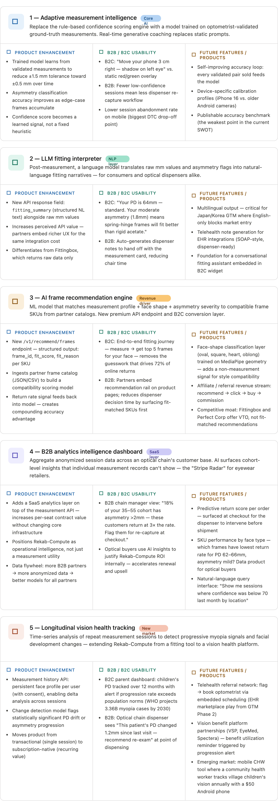
Why these five. The PRD's core weaknesses — no published accuracy validation, single-session design, and a rule-based confidence engine — are the highest-leverage AI targets. Opportunities 1 and 2 address those directly. The GTM Plan's identification of 72% of online returns linked to incorrect measurements makes the frame recommendation engine (3) the clearest commercial ROI story for B2B sales. The Competitive Analysis shows no rival combines accurate measurement with recommendation or longitudinal tracking — those are the unclaimed positions.
Sequencing recommendation. Start with 1 (adaptive confidence) in Sprint 2–3 since it improves the core product without new infrastructure. Layer 2 (LLM interpreter) alongside API v1 launch — it's a single prompt call per session. 3 (frame recommendation) is the Phase 1 commercial accelerant that turns measurement sessions into revenue events. 4 (B2B analytics dashboard) unlocks upsell at first contract renewal. 5 (longitudinal tracking) is the Phase 2–3 play that repositions the company from tooling to health platform — and is the only one that intersects the WHO's 3.36 billion myopia projection cited in the GTM.
The BIPA / GDPR flag. Opportunities 4 and 5 generate persistent and aggregate data profiles. Both require explicit consent flows, data residency choices (EU hosting for GDPR), and a legal review before launch. This is already flagged as a risk in the Competitive Analysis — it should be a gating criterion, not an afterthought.

